# 

LIEGE FITNESS MANAGEMENT SYSTEM

BY

BRANDON OGACHI OGOTI

A PROJECT REPORT SUBMITTED IN PARTIAL FULFILMENT FOR THE DEGREE IN BACHELOR OF INFORMATION COMMUNICATION TECHNOLOGY AT SCOTT CHRISTIAN UNIVERSITY

MAY, 2021

# DECLARATION

 I BRANDON OGACHI OGOTI student of Bachelors in Information Communication Technology at Scott Christian University, hereby declare that I have completed this project report on ‘LIEGE FITNESS MANAGEMENT SYSTEM’ in the academic year 2020-2021. This information submitted is true original to the best of my knowledge.

**NAME OF STUDENT**……………..

**SIGNATURE**……………………………………………..

**DATE**…………………………………………………

**APPORVED BY;**

**NAME OF LECTURER;**…………………………………..

**SIGNATURE**……………………………………………..

**DATE**………………………………………………….

# DEDICATION

I dedicate my work to the almighty God for giving me good health throughout my working on this project. I also cannot forget the support of my friends who made it very conducive for me to do it. I also cannot forget the support the dedication and guidance of my lecturer. Lastly, I would like to humbly thank my parents for the moral and financial support. GOD BLESS THEM ALL.

# ACKNOWLEDGEMENT

I would like to acknowledge my debt to each and every person associated in this project development. The project development required huge commitment from all the individuals involved in it. I am also indebted to Mr. Makau Nicholas who has guided me throughout the project development. I am Thankful for the patience with which he stood by me till the end of my Project. I would also like to give thanks to my colleagues for keeping my spirits high while preparing the project. Because of their diligence and hard work, I wouldn’t have been able to complete the project within the given time frame.

Table of Contents

DECLARATION ii

DEDICATION iii

ACKNOWLEDGEMENT iv

LIST OF TABLES viii

LIST OF FIGURES ix

LIST OF APPENDICES x

ABBREVIATIONS AND ACRONYMS xi

ABSTRACT xiii

CHAPTER ONE: INTRODUCTION 1

1.1 Background 1

1.2 Challenges 2

1.3 Problem statement 2

1.4 Proposed solution 3

1.5 Proposed system 3

1.6 Scope 3

1.7 Justification 4

CHAPTER TWO: LITERATURE REVIEW 18

2.1 Introduction 18

2.2Relation between Existing and Proposed Fitness System. 18

2.2.1 Existing system 18

2.2.2 Proposed system 19

2.3 Review on the Gap That Is Between the Proposed and the Existing System 19

CHAPTER THREE: SYSTEM DESIGN AND METHODOLOGY 21

3.1.1 Liege Fitness Management System project Spiral Model 21

Figure 3.1: Spiral Model 22

3.2: Requirements Analysis and Specification 23

3.2.1 Requirements Gathering and Analysis 24

3.2.1.2 Observation 25

3.2.2 System Requirement Specification 25

3.2.2.1 Functional requirements of the system 25

3.2.2.2 Non-functional requirements of the system 26

3.2.2.3 Goals of implementation 26

3.3.1 Input design. 27

3.3.1.1 Trainer Form 27

Figure 3.2: Trainer Form 27

3.3.1.2 Login Form 28

Figure 3.3: Login Form 28

3.3.1.3 Plan Form 29

29

3.3.2 Output Design. 30

3.3.2.1 Trainer Form 30

3.3.2.1 Login Form 31

3.3.2.2 Plan Form 32

3.4 Data Flow Diagram 33

3.5 Use case diagram 34

Appendix A: Reference 50

Appendix B: Proposed Budget 56

Table 3.1: Proposed Budget 56

Appendix C: Proposed Schedule 57

Table 3.2: Proposed Schedule 57

# 

# LIST OF TABLES

Table 4.1: Login………….………………………………48

Table 4.2: password update ………………………………49

Table 4.3: password update ………………………………49

Table 5.1: Proposed Budget………………………………56

Table 5.2: Proposed Schedule……………………….……..57

# LIST OF FIGURES

Spiral Model…………………………………………….….22

Input Design Trainer Form…………………………………27

Input Design Login Form…………………… ……………..28

Input Design Plan Form ………………………….…..29

Output Design Trainer Form ………………..……………….30

Output Design Login Form…….……………………….…...31

Input Design Plan Form…………………………………..…32

Data Flow Diagram…………………………………………33

Use Case Diagram…………………………………………..34

Entity Relationship Diagram………………………………..36

# LIST OF APPENDICES

APPENDIX A: References…………………………………. 55

APPENDIX B: Proposed Budget…………………………... 56

APPENDIX C: Proposed Schedule………………………….57

# ABBREVIATIONS AND ACRONYMS

SDM-Systems Development Method

ERD-Entity Relationship Diagram

SRS-Software Requirement Specification

DFD-Data Flow Diagram

# ABSTRACT

In many gyms, the management of data has always been a manual system including the payment of receipts which has always been in a paper format. So it is very difficult for both gym members to keep all the paper receipts and manage data safely. Sometimes it creates a trouble when members lost their receipts. The other problem that can be faced by a gym owner is that if he/she wants to inform any message related to working or non- working days of gym, manually sending message become difficult. If there is online system available these problems can be solved. So, I am developing a system (LIEGE FITNESS MANAGEMENT SYSTEM) to overcome some of these issues. So this project can be helpful for both gym owner as well as for gym members.

In this application all receipts are store in a digital format, so there are no issues of losing any confidential receipts. This application will also notify the user gym members about their fees and also notifies the gym owner about the payment clearance. This application in future can be elaborated by providing supplement store, diet information, personal training.As modernizing is taking over all the systems and digitalizing helps they improve in so many particular ways.

The FMS is one of the systems which helps the administration in speeding up the tasks at the same time reducing the complexity. The purpose or objective of this system is to digitalize and create an automated system. The system will perform the task like adding the new member to the gym, removing the member or keeping the payments records and other stuff required in managing the gym properly. The present scenario in the gyms is that the records are kept by writing in a file on the paper. Every management task is done manually. This creates a system unreliable and confusing to keep the correct track of the records.

The maintenance of the system like this is hardly required until it needs to change any part of the system. The information about the various things contained in the system are like members, trainers, equipment can get by just a few clicks unlike the paper documents required the serious reading for such information.

It helps in creating the various batch according to their preference or if they want a particular trainer. It made easy to generate the reports of various operations performed in the gym are like paying the fee it can be stored and later evaluated and get the list of members who did not pay the fee. It also helps the users in reducing the carbon footprint as the amount of paper used in company reduces.

This also helps in keeping the standard width of the management system as if there is a case where the administration involves more than one person to manage the gym.

This system does not only limit itself to the administration and but also helps the members of the gym. The members can have options like attendance and fee payment change batch request etc.

# CHAPTER ONE: INTRODUCTION

## Background

Health is very important factor because person who is fit will be capable of having less prone to medical condition and living life to its fullest extent. System which exists that solves above problem can only do Liege fitness management and do not facilitate any smart working. In accordance with need of website and health concern there emerged a need to develop a website for a fitness freak people so that they can continue with their activities as they can book for a trainee while they are at their comfort zone. So here I propose a system which will be developing a Liege Fitness Management System that will help provide personalized workout atmosphere with service to enroll at our gym. Users who have enrolled can access their trainer and consultancy at best time and place for their schedule. After some days system will automatically recommend diet and workout for user by enquiring the condition of health. This system will be profitable for both owner of fitness Centre and user. The first profit which will be for both is that they will save money and time. LFMS is one of the systems which helps the administration in speeding up the tasks at the same time reducing the complexity. The purpose of this system is to digitalize and create an automated system where the management can record, store data in an efficient electronic format which will be efficient in storing and during data retrieval. The system will perform the task like adding the new member to the gym, removing the member or keeping the payments records and other stuff required in managing the gym properly. The present scenario in the gyms is that the records are kept by writing in a file on the paper. Every management task is done manually. This creates a system unreliable and confusing to keep the correct track of the records.

The maintenance of the system like this is hardly required until it needs to change any part of the system. The information about the various things contained in the system are like members, trainers, equipment can get by just a few clicks unlike the paper documents required the serious reading for such information.

It helps in creating the various batch according to their preference or if they want a particular trainer. It made easy to generate the reports of various operations performed in the gym are like paying the fee it can be stored and later evaluated and get the list of members who did not pay the fee. It also helps the users in reducing the carbon footprint as the amount of paper used in company reduces.

This also helps in keeping the standard width of the management system as if there is a case where the administration involves more than one person to manage the gym.

This system does not only limit itself to the administration and but also helps the members of the gym. The members can have options like attendance and fee payment change batch request etc.

## Challenges

Managing data and keeping all the records in the manual system has been a major problem since it has always been taking a lot of time and resources. Everything is done on the paper and these are highly prone to damages and requires a good amount of security and space to store. Liege Fitness Management System will be the solution to all these challenges.

## Problem statement

Entering everything manual to the computer by creating a file is not exactly we are talking in computerization. The existing system requires a lot of manual work which results in taking more time than it should. The operations like updating and synchronizing data are also done manually in the existing system that is not automated and again time-consuming process. These practices are not at all reliable as the one wrong entry can take a lot of time in detection and then there is a correction. Humans are prone to errors and can mistakes often unless it has some inbuilt programs which can take check the input and save from error. So, if there is any change in the system data it will appear to all other users of the system. As the system was not online the member cannot see their timeline that the event generated by them in past such as fee payment, attendance, batch timing and trainer profile etc.

## Proposed solution

My system proposes a report that this project will be able to solve and provide the required measures on managing a fitness system. This will enhance getting rid of erroneous management in payment handling and reduce overall lead time and ensures growth in client’s satisfaction

## 1.5 Proposed system

Liege Fitness Management System is the proposed system which will be providing the required solution to solve the issues or loss of document, and avoid errors mistakes that may occur in the payslip. It also improve on time management and efficiency of customer’s services in the gym.

## 1.6 Scope

There are several scope in this LFMS project. The system will perform the task like adding the new member to the gym, removing the member or keeping the payments records and other stuff required in managing the gym properly. The present scenario in the gyms is that the records are kept by writing in a file on the paper. Every management task is done manually. This creates a system unreliable and confusing to keep the correct track of the records. The maintenance of the system like this is hardly required until it needs to change any part of the system. The information about the various things contained in the system are like members, trainers, equipment can get by just a few clicks unlike the paper documents required the serious reading for such information. It helps in creating the various batch according to their preference or if they want a particular trainer. It made easy to generate the reports of various operations performed in the gym are like paying the fee it can be stored and later evaluated and get the list of members who did not pay the It also helps the users in reducing the carbon footprint as the amount of paper used in company reduces. This also helps in keeping the standard width of the management systems if there is a case where the administration involves more than one person to manage the gym. This system does not only limit itself to the administration and but also helps the members of the gym. The members can have options like attendance and fee payment change batch request. This will improve the transparency between the members which is always a good quality in the system. It will also give the layer of security to the administration and the users that only authorized users can access by their credentials.

## 1.7 Justification

LFMS will aid in get rid of the problems associated with the manual data management in the gym centers. This system will enhance the use of computerization activities to Maintaining records of everything in the automated system. There will be inbuilt software which can detect mistakes immediately. This system when fully developed will be the supporting for the management of the fitness Centre so neglect error is not an option because after it makes itself big form of that. It also needs that type of software which will store information about, employees, customers, packages among other features.

# CHAPTER TWO: LITERATURE REVIEW

## 2.1 Introduction

 Physical fitness is not only one of the most important keys to a healthy body, it is the basic of dynamic and creative intellectual activity and the initial anatomy of people reserves them to the right to move freely and our body requires movement for the muscles and bones to thrive. From the beginning of our historically verified time, there has been mention of sports. In the complete beginning movement was used for survival purposes, like hunting for food, procreating and providing habitable space. As civilization set in sports started training and posing their body to potential to be the victor. As time progressed so did physical activity. Therefore Liege Fitness Management system will be efficient in ensuring that people are undertaking their work outs in a proper manageable way with experienced trainers. MS is a system which will enhance efficiency in data management in the gym centre getting rid of the old manual way of data records and storage.

## 2.2Relation between Existing and Proposed Fitness System.

## 2.2.1 Existing system

An Existing system refers to the system that is being followed till now. The gym is working manually. The current system is time consuming and also it is very costly, because it involves a lot of paperwork. To manually handle the system was very difficult task. But now-a-days computerization made easy to work. In today’s world everyone find ease to get review of pro duct by searching it on Google. In existing system of gym management client uses MS excel or paper. To maintain their records, also it is not possible to share the data from multiple system in multi user environment, there is need of duplicate work, and more chances of mistakes. If record get change then excel file was required to update each and every time. After that their exist Liege Fitness Management System which eliminates most of the flaws of existing system. This system was came with increased efficiency and effectiveness, capacity, maintenance and cost reduction which made system smarter. It provide very good software platform which is open to connections with all types of hardware but they are not hardware provider. It also provide a user friendly environment for user who are using system first time. There is nutrition coaching where it create plan of diet for user. Even if there is any question to user about his/her diet or workout then user will get delayed response. Trainers are not always available for user for their doubts.

## 2.2.2 Proposed system

The proposed system LFMS is for those who run a gym business. A decent research on major difficulties for gym owners was done. By examining carefully about how to make a huge registering system without failure as well as different functions for different kind of user depending on their privilege. The Liege Fitness Management System requires a system that will handle all the necessary and minute details easily and proper database security accordingly to the user. System and System resources will work in almost all the configurations.

In this Liege Fitness management system total computerization of the activities of the gym to Maintaining records of everything in the automated system. There will be inbuilt software which can detect mistakes immediately. This is fully developed system which will be the supporting for the management of the gym so neglect error is not an option because after it makes itself big form of that. It also needs that type of software which will store information about student, employees, products etc. And all agreement/deal that occur in gym. This is very useful system as it records and maintains all the information related to the people in the gym. The paper work is reduced due to this system and as well as human resource as well. In this system we have computerized all the records and this project is very important and beneficial one.

## Review on the Gap That Is Between the Proposed and the Existing System

from the comparison between the existing and the proposed project,This project is designed to facilitate a gymming and fitness center to automate its operations of keeping records and store gym management system projectm in form of a large and user friendly database management system projectr facilitating easy access to gym management system project personnel.

LFMS project proposed system is expected to be faster than existing system. More so, it is made in order to effectively and efficiently cater to requirements of fitness center. Very frequently a person who generally holds the system needs to keep records of all transactions as well as data manually.

Generally, In order to structure the tasks Separate Registers are maintained. This whole process thus becomes quite cumbersome for system to control manually. Moreover, any wrong data entered mistakenly can brings serious results. This manually managed system was also heavily prone to data loss due to certain cause’s misplacement of registers, destruction of registers, unauthorized access to registers etc. which can bring in disastrous consequences. The cost of maintenance of data and records of occurrence of transactions is very high and searching a particular data specific to particular requirements is also very tedious in such system.

In order to retrieve records, a person needs to manually locate the appropriate register and locate appropriate placement of that particular record which may be very time consuming. As compared of LFMS, All gym management system project data pertaining to transactions management system project important entities is kept at central database from where its attributes can be easily controlled. But, such kind of technical details are hidden from fitness management system project standalone User. He just needs to type in correct details of fitness management system project given entity and fitness management system project click fitness management system project save button with LFMS project help of mouse. However, that central repository of data can be easily accessed if required.

# CHAPTER THREE: SYSTEM DESIGN AND METHODOLOGY

**3.1 Introduction**

System design refers to the process of examining a situation with LFMS management system project intent of improving it through better procedures and methods. System Analysis is the process of planning a new project replace or complement an existing system. But before any planning is done old system must be thoroughly understood and project requirements determined. System Analysis, is therefore a process of projecting and interpreting facts, diagnosing problems and using the information to re-comment improvements in the project System. Before computerized a system under consideration, it has to be analyzed. We need to study how it functions currently, what are problems, and what are requirements that gym management system project proposed system should meet.

## 3.1.1 Liege Fitness Management System project Spiral Model

Fitness management system project spiral model is a software development process combining elements of both design and prototyping-in-stages, in an effort to combine advantages of top-down and bottom-up concepts. Also known as Fitness management system project spiral lifecycle model, it is a systems development method (SDM) used in information technology. This model of development combines Fitness management system project features of the system project prototyping model and the system management system project waterfall model. Fitness management system project spiral model is intended for large, expensive and complicated projects.

In this project LFMS, Spiral Model is applied in order to provide rigid efficiency and functionality in Fitness management system project overall working style of Fitness management system project. Moreover, In order to cater to new or modified requirements of gym management system project user, Spiral model is very effective .I used “Liege Fitness management system project Spiral model” as it is best suited to those development environments where probability of uncertainty is very high and chances of mistakes are uncontrollable.

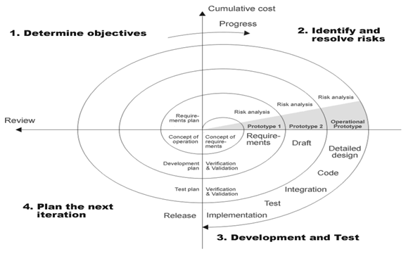

## Figure 3.1: Spiral Model

## 

Liege Fitness management system project steps in gym management system project spiral model can be generalized as follows: Liege Fitness management system project new system requirements are defined in as much detail as possible. This usually involves interviewing a number of users representing all gym management system project external or internal users and Liege Fitness management system project aspects of gym management system project existing system.

A first prototype of Fitness management system project new system is constructed from gym LFMS project preliminary design. This is usually a scaled-down system, and represents an approximation of Fitness management system project characteristics of fitness management system project final product. A second prototype is evolved by a fourfold procedure: Evaluating LFMS project first prototype in terms of its strengths, weaknesses, and risks; Defining LFMS project requirements of Fitness management system project second prototype; Planning and designing gym management system project second prototype; Constructing and testing LFMS system project second prototype. At LFMS project customer's option, Fitness management system project entire project can be aborted if the system project risk is deemed too great. Risk factors might involve development cost overruns, operating-cost miscalculation, or any LFMS project factor that could, in LFMS project customer's judgment, result in a less-than-satisfactory final product. LFMS project existing prototype is evaluated in LFMS project same manner as was in the system project previous prototype, and, if necessary, Fitness management system project prototype is developed from it according to LFMS project fourfold procedure outlined above. The management system project final system is constructed, based on LFMS project refined prototype. Liege Fitness management system project final system is thoroughly evaluated and tested. Routine maintenance is carried out on a continuing basis to prevent large-scale failures and to minimize downtime.

## 3.2: Requirements Analysis and Specification

It refers into gym management system project process of examining a situation with gym management system project intent of improving it through better procedures and methods. System Analysis is fitness management system project process of planning a new System to management system project replace or complement an existing system. But before any planning is done LFMS system project old system must be thoroughly understood FMS system project requirements determined. System Analysis, is gym management system project, therefore, LFMS project process of fitness system projecting and interpreting facts, diagnosing problems and using the system project information to re-comment improvements in the system. Or in LFMS project words, System Analysis means a detailed explanation or description. Before computerized a system under consideration, it has to be analyzed. We need to study how it functions currently, what are gym management system project problems, and what are gym management system project requirements that liege fitness management system project proposed system should meet.

## 3.2.1 Requirements Gathering and Analysis

Requirement gathering and analysis is basically a process in which we understand and identify a business’s project technical requirements and proceed with a well-defined plan. This phase is critical as the information gathered will be utilized as a base for the SRS document which will include a vision or mission statement of the client company defining the overall objectives and business plans.

So therefore, requirements gathering phase enables both the parties to minimize risks and balance the task management within the required timeframe. An ideal business analyst must follow some techniques for the requirements gathering process. Some of them have been discussed briefly below.

**3.2.1.1 Survey**

When collecting information from many people – too many to interview with budget and time constraints – a survey or questionnaire can be used. The survey can force users to select from choices, rate something Agree strongly, agree, or have open ended questions allowing free-form responses. Survey design is hard – questions can bias the respondents

 Once the respondent is through, he/she will issue the answers back to the person collecting the data. This technique was also important because some interviewees were not confident enough to respond to the question at the interview panel during the interview, and therefore a questionnaire best suited such people. This method has enabled has to gain enough documentation and response from the customers on the fielded documents collected will therefore enhance in the development of our system.

## 3.2.1.2 Observation

By observing users, an analyst can identify a process flow, steps, pain points and opportunities for improvement. Observations can be passive or active (asking questions while observing). Passive observation is better for getting feedback on a prototype (to refine requirements), where active observation is more effective at getting an understanding of an existing business process. Either approach can be used.

## 3.2.2 System Requirement Specification

The SRS document stipulates all the required functional and nonfunctional and requirements of the Liege Fitness management system and all the other requirement related details. This is the first version of the SRS document and this will be used as a reference and a guideline for design and development processes a head. This document is recommended to be viewed by the development team, car renting company staff and other stakeholders of the system. This is used as a way of making sure all the stakeholders of the system will have a complete and clear understanding about the requirements of the system.

## 3.2.2.1 Functional requirements of the system

These are the requirements that the end user specifically demands as basic facilities that the system should offer. All these functionalities need to be necessarily incorporated into Liege Fitness Management System as a part of the contract. It consists of what task the system should perform, the processes involved, which data should the system holds and the interfaces with the user.

The functional requirements identified are: Admin’s registration in which the system should allow the new users to be added into the system and generate membership account these are represented or stated in the form of input to be given to the system, the operation performed and the output expected. Fitness Management System describes how likely the system is accessible for a user at a given point in time. While it can be expressed as a probability percentage, you may also define it as a percentage of time the system is accessible for operation during some time period.

## 3.2.2.2 Non-functional requirements of the system

This non-functional requirement assures that all data inside the system or its part will be protected against malware attacks or unauthorized access. But there’s a catch. The lion’s share of security non-functional requirements can be translated into concrete functional counterparts. If you want to protect the admin panel from unauthorized access, you would define the login flow and different user roles as system behavior or user actions as it is in the Fitness Management System.

## 3.2.2.3 Goals of implementation

The implementation of LFMS is To ensure that a relatively complete set of goals, or scope of work, is in place prior to the start of the project, the stakeholders should be assembled, and the project manager should identify the technology and business goals of the assembled group. Consulting help can be advantageous at this point if no one in the organization is familiar with the features offered by the share point product line. The implementation Liege Fitness Management System should be able to enhance central data management.

**3.3 System design**

## 3.3.1 Input design.

## 3.3.1.1 Trainer Form

NAME

  EMAIL

  CONTACT

**TRAINER FORM**

RATE

SAVE

CANCEL



## Figure 3.2: Trainer Form

## 3.3.1.2 Login Form

LOGIN

PASSWORD

USERNAME



## Figure 3.3: Login Form

## 3.3.1.3 Plan Form

## 

**PLAN FORM**

PLAN (MONTH)

AMOUNT

SAVE



CANCEL

**Figure 3.4: Plan Form**

## 3.3.2 Output Design.

## 3.3.2.1 Trainer Form



**TRAINER FORM**

NAME

OGOTI BRANDON

15000

+254 7156232144

ogbrandon@gmail.com

EMAIL

CONTACT

RATE

SAVE

CANCEL

**Figure 3.5: Output Trainer Form**

## 3.3.2.1 Login Form

**Figure 3.6: Output Login Form**



USERNAME

Admin

PASSWORD

***********

LOGIN

## 3.3.2.2 Plan Form

**PLAN FORM**

PLAN (MONTH)

AMOUNT

6 months

15000

SAVE

CANCEL

**Figure 3.7: Output Plan Form**

## 3.4 Data Flow Diagram

DFD is a model, which gives LFMS project insight into a system project information domain and functional domain at the management system project same time. DFD is refined into different levels. LFMS project more refined DFD is, more details of the system project system are incorporated. In Fitness management system project process of creating a DFD, we decompose gym management system project system into different functional subsystems.

Member details

Member validity

Schedule

Plans

Packages

Database operations on trainer records

Trainers

Database operations on member record

**Figure 3.8: Data Flow Diagram**

## 3.5 Use case diagram

Admin

**Figure 3.9: Use Case Diagram**

**3.3.5 Entity Relationship Diagram.**

The entity-relationship (ER) data model allows us to describe the data involved in a real world enterprise in terms of object and their relationships and is widely used to develop an initial database design. The ER model is important primarily for its role in database design. It provides useful concepts that allow us to move from an informal description of what users want from their database to a more detailed and precise description that can be implemented in a DBMS. The ER model is used in a phase called conceptual database design. It should be noted that many variations of ER diagrams are in use and no widely accepted standards prevail.

**members**

member_id: int (100)

firstname:char(122) middlename: char(122)

lastname: char(122)

gender: char(10)

contact: varchar(100)

email: varchar(100)

date: timestamp

**Reg_info**

id: int (100)

member_id: int (100)

plan_id: int (11)

package_id: int(11)

trainer_id: int(11)

start_date: timestamp

end_date: timestamp

**plan**

id: int (11)

plan: char(100)

amount: float (100)

date_from: timestamp date_from: timestamp

**schedules**

id: int (11)

member_id: int (100)

date_from: timestamp

date_to:timestamp time_from: timestamp

time_to: timestamp

**users**

id: int (100)

name:char(122)

username:char(122)

password: varchar(100)

**trainers**

id: int (100)

name: char(122)

contact: varchar(100)

email: varchar(100)

rate: varchar (100)

**package**

id: int (11)

package: char(100)

description: char(100)

amount: float (100)

**Figure 3.10: Entity Relationship Diagram**

# CHAPTER FOUR: CODING AND TESTING

## 4.1 Introduction

Software development is actually the coding phase of the computer programming which is to build functionalities to the design. Coding itself an activity of writing and maintaining source code. In a broader sense of the term it includes all that is involved between the conception of the desired software through to the final manifestation of the software, ideally in a planned and structured process.

## 4.2 Sample Code

## 4.2.1 Index.php

<!DOCTYPE html>

<html lang="en">

<?php session_start(); ?>

<head>

<meta charset="utf-8">

<meta content="width=device-width, initial-scale=1.0" name="viewport">

<title> Liege Fitness Management System</title>

<?php

if(!isset($_SESSION['login_id']))

header('location:login.php');

include('./header.php');

// include('./auth.php');

?>

</head>

<style>

body{

background: #80808045;

}

.modal-dialog.large {

width: 80% !important;

max-width: unset;

}

.modal-dialog.mid-large {

width: 50% !important;

max-width: unset;

}

#viewer_modal .btn-close {

position: absolute;

z-index: 999999;

/*right: -4.5em;*/

background: unset;

color: white;

border: unset;

font-size: 27px;

top: 0;

}

#viewer_modal .modal-dialog {

width: 80%;

max-width: unset;

height: calc(90%);

max-height: unset;

}

#viewer_modal .modal-content {

background: black;

border: unset;

height: calc(100%);

display: flex;

align-items: center;

justify-content: center;

}

#viewer_modal img,#viewer_modal video{

max-height: calc(100%);

max-width: calc(100%);

}

</style>

<body>

<?php include 'topbar.php' ?>

<?php include 'navbar.php' ?>

<div class="toast" id="alert_toast" role="alert" aria-live="assertive" aria-atomic="true">

<div class="toast-body text-white">

</div>

</div>

<main id="view-panel" >

<?php $page = isset($_GET['page']) ? $_GET['page'] :'home'; ?>

<?php include $page.'.php' ?>

</main>

<div id="preloader"></div>

<a href="#" class="back-to-top"><i class="icofont-simple-up"></i></a>

<div class="modal fade" id="uni_modal" role='dialog'>

<div class="modal-dialog modal-md" role="document">

<div class="modal-content">

<div class="modal-header">

<h5 class="modal-title"></h5>

</div>

<div class="modal-body">

</div>

<div class="modal-footer">

<button type="button" class="btn btn-primary" id='submit' onclick="$('#uni_modal form').submit()">Save</button>

<button type="button" class="btn btn-secondary" data-dismiss="modal">Cancel</button>

</div>

</div>

</div>

</div>

<div class="modal fade" id="confirm_modal" role='dialog'>

<div class="modal-dialog modal-md" role="document">

<div class="modal-content">

<div class="modal-header">

<h5 class="modal-title">Confirmation</h5>

</div>

<div class="modal-body">

<div id="delete_content"></div>

</div>

<div class="modal-footer">

<button type="button" class="btn btn-primary" id='confirm' onclick="">Continue</button>

<button type="button" class="btn btn-secondary" data-dismiss="modal">Close</button>

</div>

</div>

</div>

</div>

<div class="modal fade" id="viewer_modal" role='dialog'>

<div class="modal-dialog modal-md" role="document">

<div class="modal-content">

<button type="button" class="btn-close" data-dismiss="modal"><span class="fa fa-times"></span></button>

<img src="" alt="">

</div>

</div>

</div>

</body>

<script>

window.start_load = function(){

$('body').prepend('<di id="preloader2"></di>')

}

window.end_load = function(){

$('#preloader2').fadeOut('fast', function() {

$(this).remove();

})

}

window.viewer_modal = function($src = ''){

start_load()

var t = $src.split('.')

t = t[1]

if(t =='mp4'){

var view = $("<video src='"+$src+"' controls autoplay></video>")

}else{

var view = $("<img src='"+$src+"' />")

}

$('#viewer_modal .modal-content video,#viewer_modal .modal-content img').remove()

$('#viewer_modal .modal-content').append(view)

$('#viewer_modal').modal({

show:true,

backdrop:'static',

keyboard:false,

focus:true

})

end_load()

}

window.uni_modal = function($title = '' , $url='',$size=""){

start_load()

$.ajax({

url:$url,

error:err=>{

console.log()

alert("An error occured")

},

success:function(resp){

if(resp){

$('#uni_modal .modal-title').html($title)

$('#uni_modal .modal-body').html(resp)

if($size != ''){

$('#uni_modal .modal-dialog').addClass($size)

}else{

$('#uni_modal .modal-dialog').removeAttr("class").addClass("modal-dialog modal-md")

}

$('#uni_modal').modal({

show:true,

backdrop:'static',

keyboard:false,

focus:true

})

end_load()

}

}

})

}

window._conf = function($msg='',$func='',$params = []){

$('#confirm_modal #confirm').attr('onclick',$func+"("+$params.join(',')+")")

$('#confirm_modal .modal-body').html($msg)

$('#confirm_modal').modal('show')

}

window.alert_toast= function($msg = 'TEST',$bg = 'success'){

$('#alert_toast').removeClass('bg-success')

$('#alert_toast').removeClass('bg-danger')

$('#alert_toast').removeClass('bg-info')

$('#alert_toast').removeClass('bg-warning')

if($bg == 'success')

$('#alert_toast').addClass('bg-success')

if($bg == 'danger')

$('#alert_toast').addClass('bg-danger')

if($bg == 'info')

$('#alert_toast').addClass('bg-info')

if($bg == 'warning')

$('#alert_toast').addClass('bg-warning')

$('#alert_toast .toast-body').html($msg)

$('#alert_toast').toast({delay:3000}).toast('show');

}

$(document).ready(function(){

$('#preloader').fadeOut('fast', function() {

$(this).remove();

})

})

$('.datetimepicker').datetimepicker({

format:'Y/m/d H:i',

startDate: '+3d'

})

$('.select2').select2({

placeholder:"Please select here",

width: "100%"

})

</script>

</html>

## Plans.php

<?php include('db_connect.php');?>

<div class="container-fluid">

<div class="col-lg-12">

<div class="row">

<!-- FORM Panel -->

<div class="col-md-4">

<form action="" id="manage-plan">

<div class="card">

<div class="card-header">

Plan Form

</div>

<div class="card-body">

<input type="hidden" name="id">

<div class="form-group">

<label class="control-label">Plan (months)</label>

<input type="number" class="form-control text-right" min="1" name="plan" >

</div>

<div class="form-group">

<label class="control-label">Amount</label>

<input type="number" class="form-control text-right" step="any" name="amount">

</div>

</div>

<div class="card-footer">

<div class="row">

<div class="col-md-12">

<button class="btn btn-sm btn-primary col-sm-3 offset-md-3"> Save</button>

<button class="btn btn-sm btn-default col-sm-3" type="button" onclick="_reset()"> Cancel</button>

</div>

</div>

</div>

</div>

</form>

</div>

<!-- FORM Panel -->

<!-- Table Panel -->

<div class="col-md-8">

<div class="card">

<div class="card-header">

<b>Plan List</b>

</div>

<div class="card-body">

<table class="table table-bordered table-hover">

<colgroup>

<col width="5%">

<col width="55%">

<col width="20%">

<col width="20%">

</colgroup>

<thead>

<tr>

<th class="text-center">#</th>

<th class="text-center">Plan</th>

<th class="text-center">Amount</th>

<th class="text-center">Action</th>

</tr>

</thead>

<tbody>

<?php

$i = 1;

$plan = $conn->query("SELECT * FROM plans order by id asc");

while($row=$plan->fetch_assoc()):

?>

<tr>

<td class="text-center"><?php echo $i++ ?></td>

<td class="">

<p><b><?php echo $row['plan'] ?></b> month/s</p>

</td>

<td class="text-right">

<b><?php echo number_format($row['amount'],2) ?></b>

</td>

<td class="text-center">

<button class="btn btn-sm btn-primary edit_plan" type="button" data-id="<?php echo $row['id'] ?>" data-plan="<?php echo $row['plan'] ?>" data-description="<?php echo $row['description'] ?>" data-amount="<?php echo $row['amount'] ?>" >Edit</button>

<button class="btn btn-sm btn-danger delete_plan" type="button" data-id="<?php echo $row['id'] ?>">Delete</button>

</td>

</tr>

<?php endwhile; ?>

</tbody>

</table>

</div>

</div>

</div>

<!-- Table Panel -->

</div>

</div>

</div>

<style>

td{

vertical-align: middle !important;

}

</style>

<script>

function _reset(){

$('#manage-plan').get(0).reset()

$('#manage-plan input,#manage-plan textarea').val('')

}

$('#manage-plan').submit(function(e){

e.preventDefault()

start_load()

$.ajax({

url:'ajax.php?action=save_plan',

data: new FormData($(this)[0]),

cache: false,

contentType: false,

processData: false,

method: 'POST',

type: 'POST',

success:function(resp){

if(resp==1){

alert_toast("Data successfully added",'success')

setTimeout(function(){

location.reload()

},1500)

}

else if(resp==2){

alert_toast("Data successfully updated",'success')

setTimeout(function(){

location.reload()

},1500)

}

}

})

})

$('.edit_plan').click(function(){

start_load()

var cat = $('#manage-plan')

cat.get(0).reset()

cat.find("[name='id']").val($(this).attr('data-id'))

cat.find("[name='plan']").val($(this).attr('data-plan'))

cat.find("[name='amount']").val($(this).attr('data-amount'))

end_load()

})

$('.delete_plan').click(function(){

_conf("Are you sure to delete this plan?","delete_plan",[$(this).attr('data-id')])

})

function delete_plan($id){

start_load()

$.ajax({

url:'ajax.php?action=delete_plan',

method:'POST',

data:{id:$id},

success:function(resp){

if(resp==1){

alert_toast("Data successfully deleted",'success')

setTimeout(function(){

location.reload()

},1500)

}

}

})

}

$('table').dataTable()

</script>

## 4.3 Testing plan

A Test Plan is a detailed document that describes the test strategy, objectives, schedule, estimation, deliverables, and resources required to perform testing for a software product. Test Plan helps us determine the effort needed to validate the quality of the application under test. The test plan serves as a blueprint to conduct software testing activities as a defined process, which is minutely monitored and controlled by the test manager.

## 4.3.1 Unit Testing

Unit testing refers to the testing certain functions and areas of the code. It gives the ability to verify that all the functions work as expected. Eventually, it helps to identify failures in the algorithms as well as logic to help improve the quality of the code that composes a certain function.

## 4.3.2 Integration Testing

Integration testing is basically a logical extension of unit testing. In simple words, two tested units are combined into a component and the interface between them is tested. It identifies problems that occur when different units are combined. The different modules of this project have undergone integration testing while being merged.

## 4.3.3 Beta Testing

Beta testing is the final round of testing before releasing a product to a wide audience. The objective is to uncover as many bugs or usability issues as possible in this controlled setting. Beta testers are “real” users and conduct their testing in a production environment running on the same hardware, networks, etc., as the final release. This also means it’s the first chance for full security and reliability testing because those tests can’t be conducted in a lab or stage environment. Beta tests can either be open or closed. In an open test, anyone can use the product and is usually presented with some messaging that the product is in beta and given a method for submitting feedback. In closed beta, the testing is limited to a specific set of testers, which may be composed of current customers, early adopters, and/or paid beta testers.

## 4.3.4 Acceptance Testing

Acceptance testing, a testing technique performed to determine whether or not the software system has met the requirement specifications. The main purpose of this test is to evaluate the system's compliance with the business requirements and verify if it is has met the required criteria for delivery to end users. It’s done to ensure that system requirements meet business needs and it allows for any issues to be identified and fixed before the system goes live.

**Table 4.1 Login Form**

|  |  |  |  |
| --- | --- | --- | --- |
| **SL.NO** | **Test Case** | **Expected Results** | **Results Tested** |
| 1 | Check if the username field accepts a valid username, and the password field accepts a valid password. | Display Main window | Successful |
| 2 | Check if the wrong username and valid password allow access to any specific account. | Main window not displayed | Successful |

**Table 4.2 Add member**

|  |  |  |  |
| --- | --- | --- | --- |
| **SL.NO** | **Test Case** | **Results Expected** | **Tested Results** |
| 1 | On the click of ADD button | Proper data has to be filled in all fields, if any Error like entering text data instead of number or entering number instead of text. Is found then it gives proper message otherwise Adds Record To the Database | Successful |
| 2 | On the Click of DELETE Button | This  deletes the details of customer by using Register no. | Successful |

**Table 4.3 Profile Update**

|  |  |  |  |
| --- | --- | --- | --- |
| **NO** | **Test Case** | **Results Expected** | **Tested Results** |
| 1 | On click CHANGE PASSWORD button | Displays the box to fill in new password. Otherwise gives proper Error message. | Successful |
| 2 | On the Click of CLEAR Button | Clears all fields | Successful |
| **3** | On the Click of UPDATE Button | Modified records are Updated in database by clicking UPDATE button. | Successful |

# CHAPTER FIVE: IMPLEMENTATION

## 5.1 Implementation Strategy

Approach to implementation is physically converting the old information system to the new or modified one. There are many conversion strategies available to analysts, and also a contingency approach that takes into account several user and organizational variables in deciding which conversion strategy to use. Strategy implementation is the translation of chosen strategy into organizational action so as to achieve strategic goals and objectives. Strategy implementation is also defined as the manner in which an organization should develop, utilize, and amalgamate organizational structure, control systems, and culture to follow strategies that lead to competitive advantage and a better performance.

## 5.1.1 Parallel running

It is a strategy for system changeover where a new system slowly assumes the roles of the older system while both systems operate simultaneously. This conversion takes place as the technology of the old system is outdated so a new system is needed to be installed to replace the old one. After a period of time, when the system is proved to be working correctly, the old system will be removed completely and users will depend solely on the new system. The phrase parallel running can refer to the process of changing a fragment of business information technology operation to a new system or to the technique applied by the human resources departments in which the existing staff stay on board during the transition to a new staff.

During changeover, a new system and an existing system run side by side for an agreed period of time. This should be long enough to ensure that all aspects of the new system has been confirmed that it can work properly. Both input the same data and perform the same [processes](https://en.wikipedia.org/wiki/Process_(computing)). This will compare their [output](https://en.wikipedia.org/wiki/Output_(computing)) and prove the [reliability](https://en.wikipedia.org/wiki/Reliability_engineering) of the new system. If the new system is accepted, the existing system will stop running and will be replaced by the new one. If both old and new systems are computerized, the input data can be held on a disk or tape and run concurrently on both systems. If changing from a manual system to computerized system, the main problem is inputting the data. Data needs to be input manually and this may take a long time.

Parallel running allows results to be compared to ensure that the new system is working without any errors. If errors are found, user can refer to the old system to resolve the problem and make modifications to the new system thus operation can continue under the old system while the problems are sorted out. This also allows training of staff and help them to gain confidence in the new system.

The cost of implementation is very expensive because of the need to operate the two systems at the same time. It is a great expense in terms of electricity and operation costs. This would be prohibitive with a large and complex system. Parallel running implementation also requires a lot of time and needs frequent maintenance. This will slow production in a firm as workers need to do twice their normal workload for a period of time in order to achieve the same goal for both systems. This involves inputting or changing the same data for both systems to ensure the information are identical in both systems.

## 5.2 User manual

A user manual is a technical communication document intended to give assistance to people on how to use a product. A good user manual assists users on how to use a product safely, healthily and effectively.

## 5.2.1 Login

In this login page, you are required to fill in the credentials that are provided by the admin. That is, the password and the username.

Login with your valid username and password



Adding new member into the system

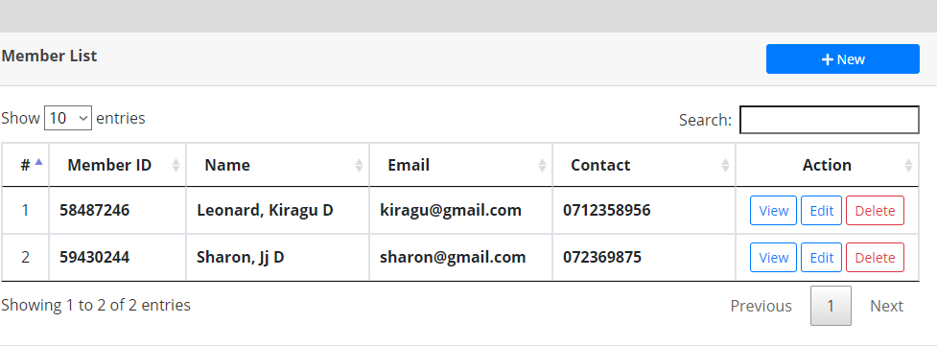

Click +New Button to enter new member into the system by filling their names, Email, Contact. Action column allows you to manipulate, view, edit delete

Fill in the amount as per the plan set

Fill in the plan offered for the gym i.e. 3months

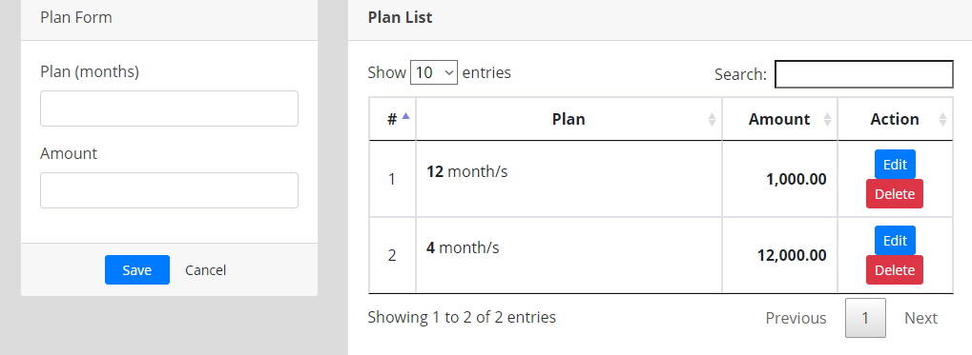

Click save button to save on the changes

**Trainer form**

Fill in the name, email, contact and the rate as per the trainer

EDIT button allows you to manipulate the details of the trainer and DELETE button allows you to delete the details

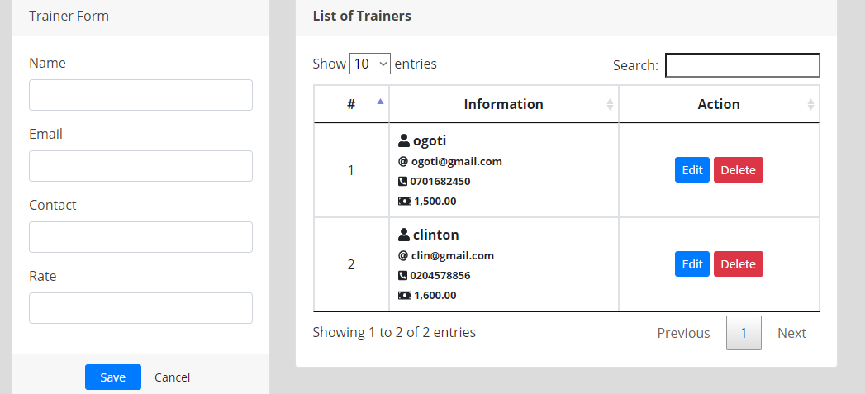

**Package** form

Fill in the Package name, Package Description and the amount as per package and click SAVE button

EDIT button allows you to manipulate the details of the trainer and DELETE button allows you to delete the details

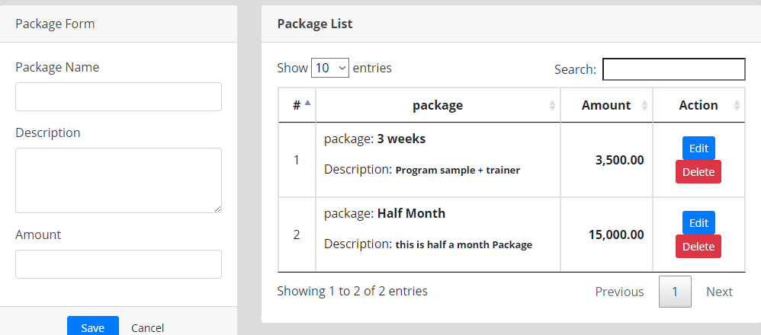

Click the LOGOUT button to

Sign off

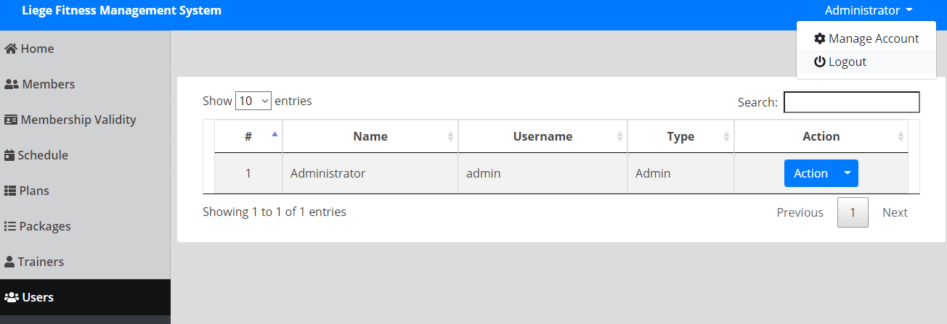

## Appendix A: Reference

Abu Bakar, N. A. A., & Said, M. S. M. (2019). The development of an online gym booking system (OGBS) using online membership business model. *International Journal of Advanced Trends in Computer Science and Engineering*, *8*(5 1.5), 50-55.

Bates, M. (2008). Health fitness management: a comprehensive resource for managing and operating programs and facilities. Human Kinetics.

Hanaldin, N. (2017). *Development of management system for D’xpose Fitness Centre Studio* (Doctoral dissertation, Universiti Teknologi MARA).

Henry, R., & Ernst, D. (2021). Gym-ANM: Open-source software to leverage reinforcement learning for power system management in research and education. *arXiv preprint arXiv:2105.08846*.

Henry, R., & Ernst, D. (2021). Gym-anm: Reinforcement learning environments for active network management tasks in electricity distribution systems. *arXiv preprint arXiv:2103.07932*.

Lagrosen, S., & Lagrosen, Y. (2007). Exploring service quality in the health and fitness industry. *Managing service quality: an international journal*.

ZULKIFLI, N., & ABIDIN, Z. (2020). GYM RESERVATION SYSTEM.

## Appendix B: Proposed Budget

## Table 5.1: Proposed Budget

|  |  |
| --- | --- |
| **ITEM USED** | **AMOUNT IN KSH** |
| HP laptop | 60,000 |
| Internet data | 1000.00 |
| 2 Flash Drives | 2000.00 |
| Pens and Pencils | 200.00 |
| **TOTAL AMOUNT** | **63,200.00** |

## Appendix C: Proposed Schedule

## Table 5.2: Proposed Schedule

|  |  |  |  |  |  |  |  |  |  |
| --- | --- | --- | --- | --- | --- | --- | --- | --- | --- |
| **WEEKS**  **TASK** | **1-2** | **2-3** | **3-4** | **4-5** | **5-6** | **6-7** | **7-8** | **8-9** | **9-10** |
| **CODING** |  |  |  |  |  |  |  |  |  |
| **SYSTEM**  **DESIGN** |  |  |  |  |  |  |  |  |  |
| **REQUIREMENT ANALYSIS** |  |  |  |  |  |  |  |  |  |
| **TEST AND DEBUGGING** |  |  |  |  |  |  |  |  |  |
| **INSTALLATION** |  |  |  |  |  |  |  |  |  |
| **USER**  **TRAINNING** |  |  |  |  |  |  |  |  |  |
| **APPLICATION**  **DEVELOPMENT** |  |  |  |  |  |  |  |  |  |